

**GROUP ASSIGNMENT**

**TECHNOLOGY PARK MALAYSIA**

**CT126-3-2-CTF**

**PRACTICAL CTF STRATEGIES**

**APD2F2309CS(CYB)**

**HANDOUT DATE:  15 FEBRUARY 2024**

**HAND-IN DATE:  29 APRIL 2024**

**WEIGHTAGE: 60%**

|  |  |
| --- | --- |
| **NAME:** | **TP NUMBER:** |
| **YAZEN ABOBAKR AHMED AL-MEHDHAR** | **TP069210** |
| **ABDULRAHMAN GAMIL MOHAMMED AHMED** | **TP071012** |
| **HAZIQ IRFAN BIN RADZALI** | **TP072306** |

Contents

1. INTRODUCTION 3

2. Shark of Wire 2 (Forensics) (SKRCTF) 4

3. De Tuna My Fish (Cryptography) (SKRCTF) 18

4. Slot Machine (Web) (SKRCTF) 27

5. REFERENCES 48

# INTRODUCTION

CTF, or Capture The Flag, is a cybersecurity challenge where participants solve tasks across various domains to find hidden flags, and testing skills and foster collaboration within the cybersecurity community.

This collection presents solutions to diverse CTF challenges spanning Cryptography, Forensics, and Web Security domains. Challenges in each category have been completed, offering insights into problem-solving approaches. From deciphering cryptographic puzzles to conducting digital investigations and exploiting web vulnerabilities, each writeup delves into methodologies employed to conquer tasks. Whether a seasoned cybersecurity enthusiast or a curious beginner, readers are invited to explore concise analyses for inspiration and guidance in navigating the dynamic world of CTF competitions.

# [Shark of Wire 2 (Forensics) (SKRCTF)](https://skrctf.me/challenges#Shark%20Of%20Wire%202)

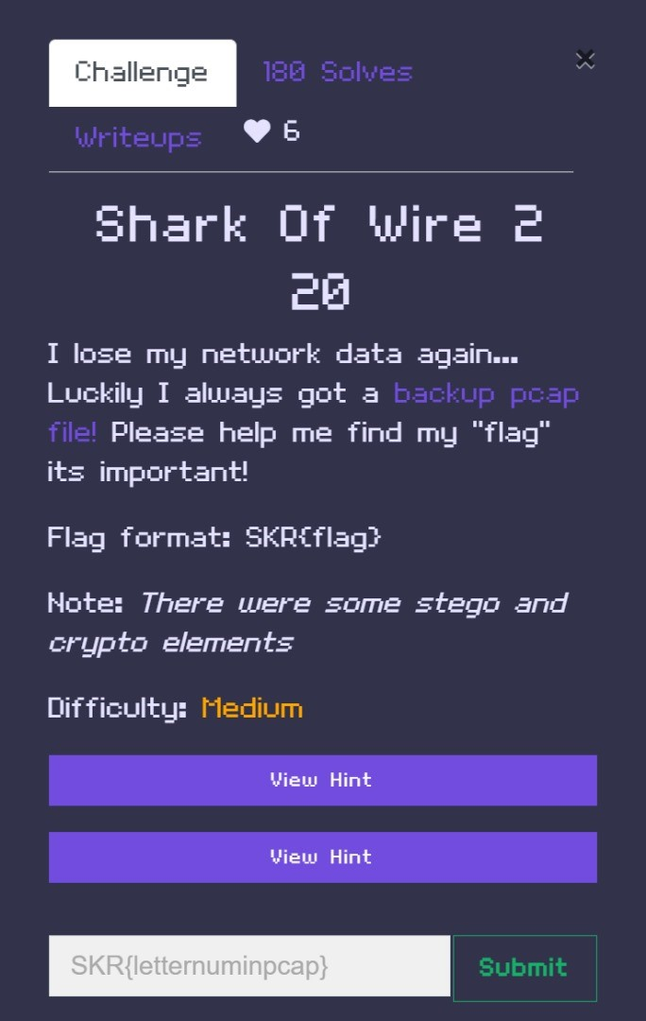

In this challenge it is required to analyze the Pcap to find out what the flag is, P ap is the file format used to hold network packet data that has been recorded from a network interface, or packet capture. It is frequently linked to troubleshooting and network analysis tasks, but in this case it is used to solve the CTF challenge, You can open a PCAP file with many tools such as PRTG network monitor, network miner, and Wireshark, the best tool and the one that is even hinted in the question is wireshark

When it comes to the hints, The hints that can be observed before starting the challenge are:

1. The name of the challenge “shark of wire” referencing the tool that will be used “Wireshark”
2. “Network data” as a sign for those who don’t know what Pcap is
3. The hints given are:
   1. 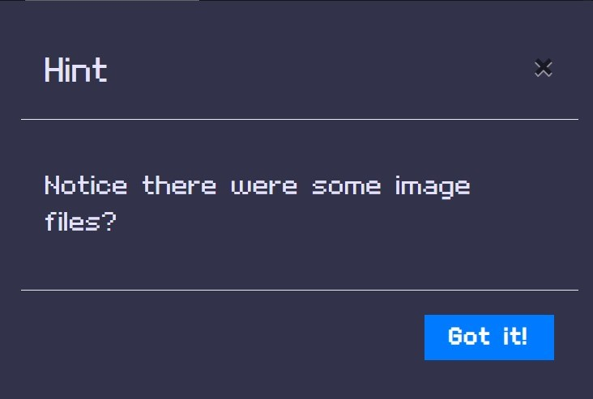
   2. 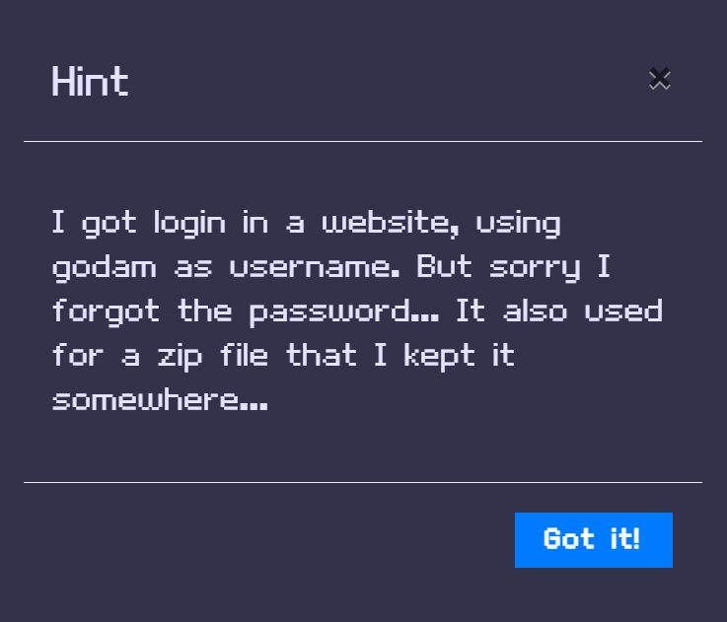

First, when opening the file, since it was mentioned in the hint that the data is related to a login, we filter the Http protocol packets as a start.

There are many packets with different information that could be false sometimes, going through them :

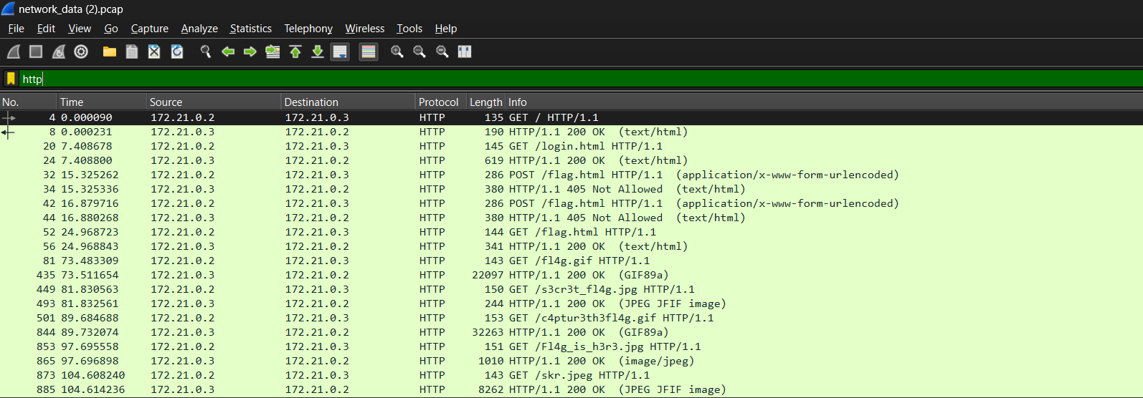

We include HTTP in the filter to retrieve data, view the password of the specified website mentioned in the hint, and also extract the images as instructed in the hint.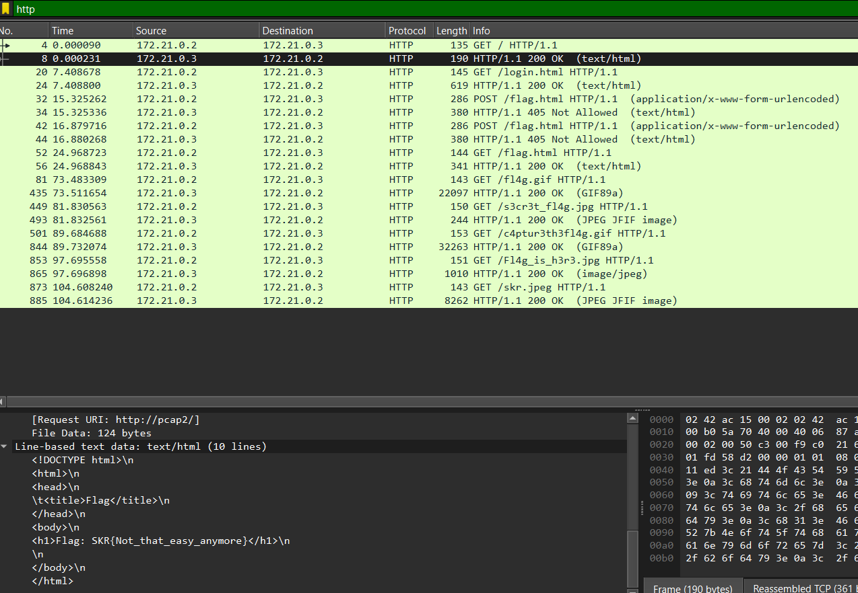

The initial HTML file "login.html" indicates that there's a flag labeled as SKR{Not_easy_anymore}, suggesting it's a deceptive flag.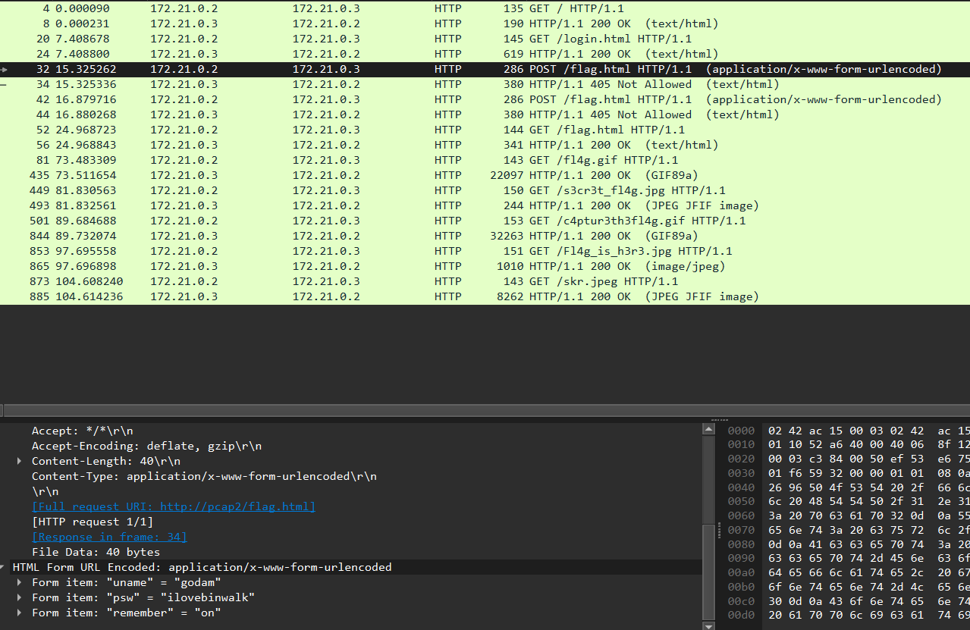

In the second HTML file "flag.html," we find the username and password of the user: username: godam and password: ilovebinwalk.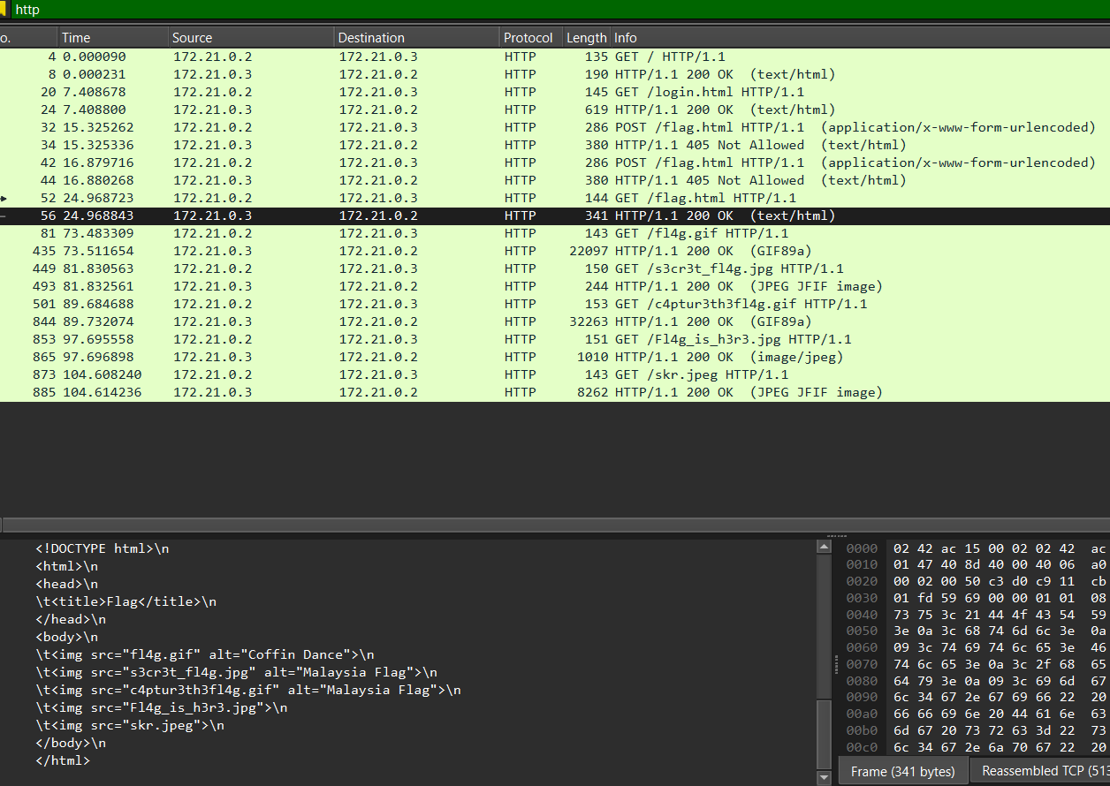

Continuing, it appears that this HTML file references or includes five images that were either used or captured in the Wireshark file: fl4g.gif, s3rc3t_fl4g.jpg, c4ptur3th3fl4g.gif, fl4g_is_h3r3.jpg, and skr.jpeg. So, based on the five mentioned images, it seems like the next step would be to export them to your machine and begin analyzing them for any hidden information or clues.

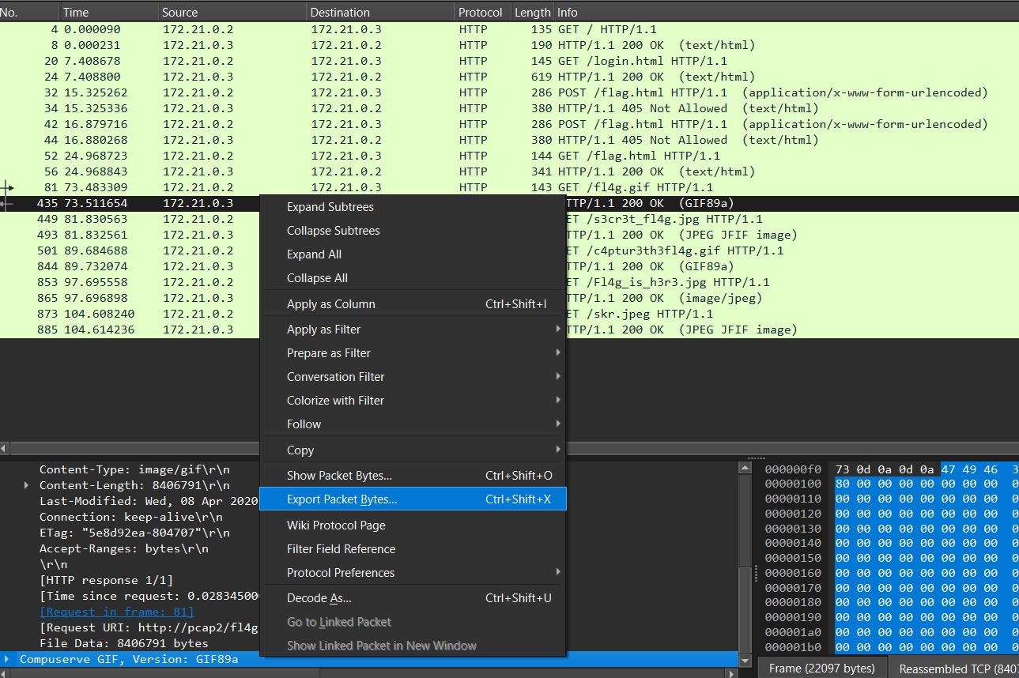

After clicking on the HTTP page, you'll find information about the packets and protocols used on the network displayed at the bottom. To focus on exporting the images for analysis, you can click on the last option in the toolbar at the bottom to export the file.

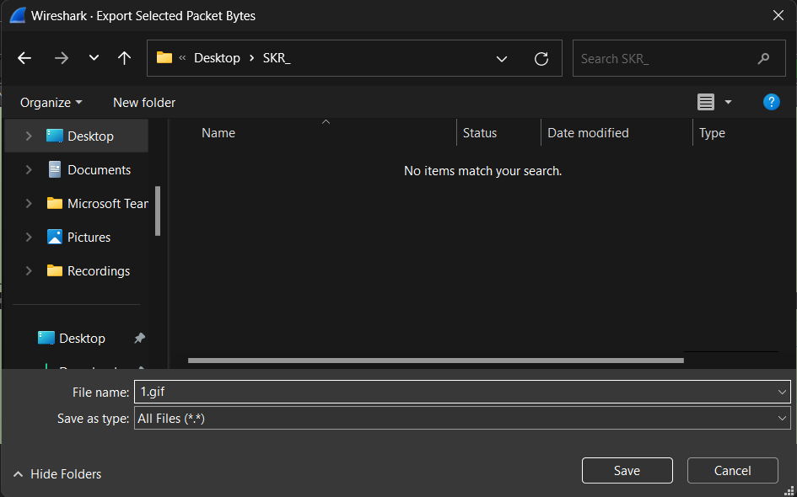

After clicking on export, the window above will appear. You need to name the file and add the desired file extension, such as .jpg, .gif, or .jpeg, depending on the file format of the images you're downloading. Make sure to select "All Files (*.*)" as the file type to enable saving the file with the extension you've specified. This will ensure that you can save the downloaded file with the desired extension.

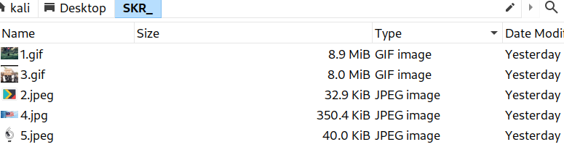

Once we've exported and downloaded all five images, the next step is to transfer them to the Kali Linux machine. After transferring, you can inspect the metadata of the images and utilize various tools for analysis and manipulation.

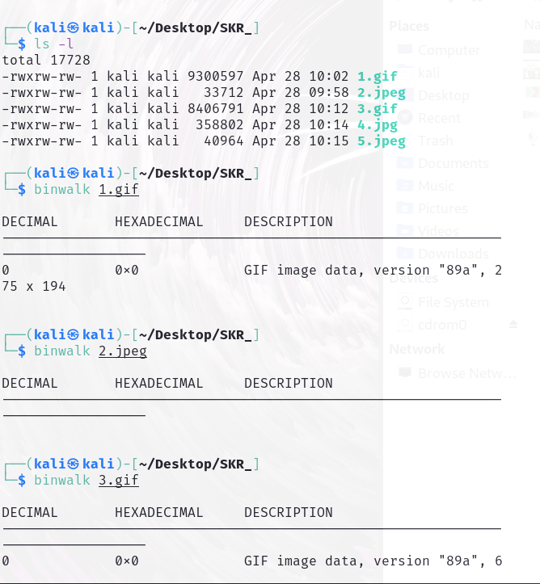

In the above images, it shows the command and the use of the binwalk tool to check if there is some hidden files inside the images ‘binwalk NameOfImage’, binwalk is usually used to find embedded files and executable code withing binary images.

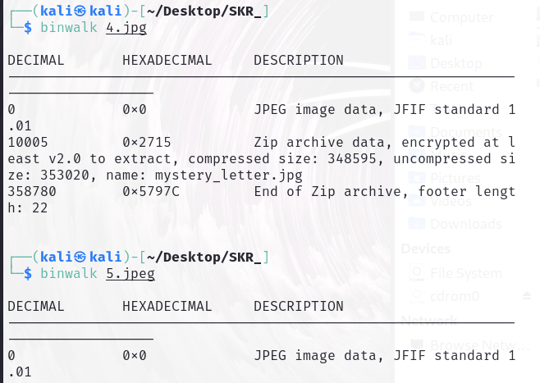

In the two images provided, it demonstrates the command and usage of the binwalk tool to check for hidden files within the images. The command format is 'binwalk NameOfImage'. This command will analyze the specified image file for any embedded or hidden files. After using the binwalk command on the five images, it appears that image number 4 contains some hidden files.

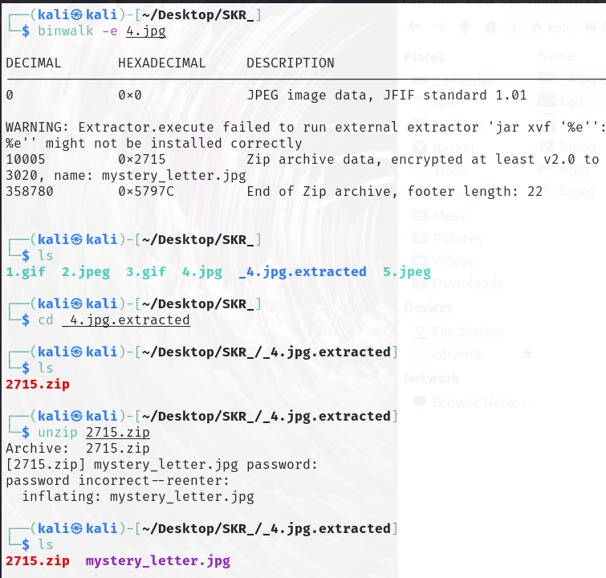

To extract the hidden files inside the image 4.jpg using the binwalk tool, you would indeed use the command "binwalk -e 4.jpg", where the '-e' flag denotes extracting files from the specified image.

After extracting the files, you can list the contents of the directory using the "ls" command. You'll see a new directory created, typically with the name of the image followed by ".extracted". You can navigate into this directory using the "cd" command followed by the directory name.

Once inside the extracted directory, you can list the files again to view its contents. If you find a zip file, such as "2715.zip," you can unzip it using the "unzip 2715.zip" command. This will prompt you for a password.

Recalling the password obtained earlier from the HTML file, which is "ilovebinwalk," you can enter it to unzip the folder and access its contents.

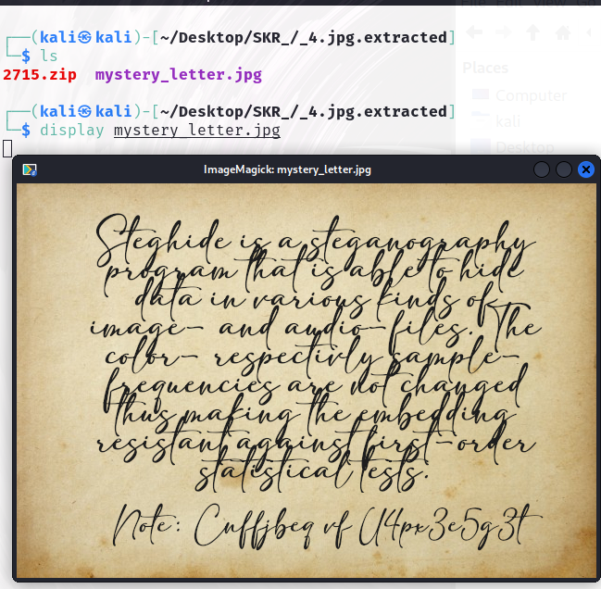

This is the exported image that was hidden within 4.jpg , as it might be hard to read through it, here is what it says:  
"Steghide is a steganography program that is able to hide data in various kinds of image and audio files... etc”, what is mostly important here is the note at the bottom that says:

“Note: Cnffjbeq vf U4px3e5g3t”

This is am encrypted message that might contain something important, to decrypt it there is various methods, such as using Dcode website which is toolkit website for decryption and ciphertexts, another way could be using a Python code to decrypt the used cipher.

There are usually signs to recognise the used algorithm for decryption, for this ciphertext, it is obvious that the letters has been shifted, so we test Rot13 (or Rotate 13) which is a simple letter substitution cipher that replaces each letter in a text with the letter 13 positions ahead or behind it in the alphabet.

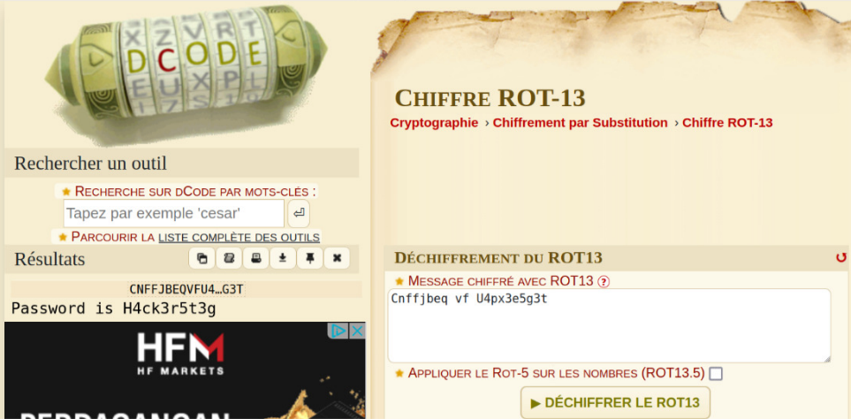

Decrypting the text "Cnffjbeq vf U4px3e5g3t" with the ROT13 cipher, we get "Password is H4ck3r5t3g." This decrypted text "H4ck3r5t3g" is the password needed to extract hidden files inside the mystery_letter.jpg using the steghide tool.

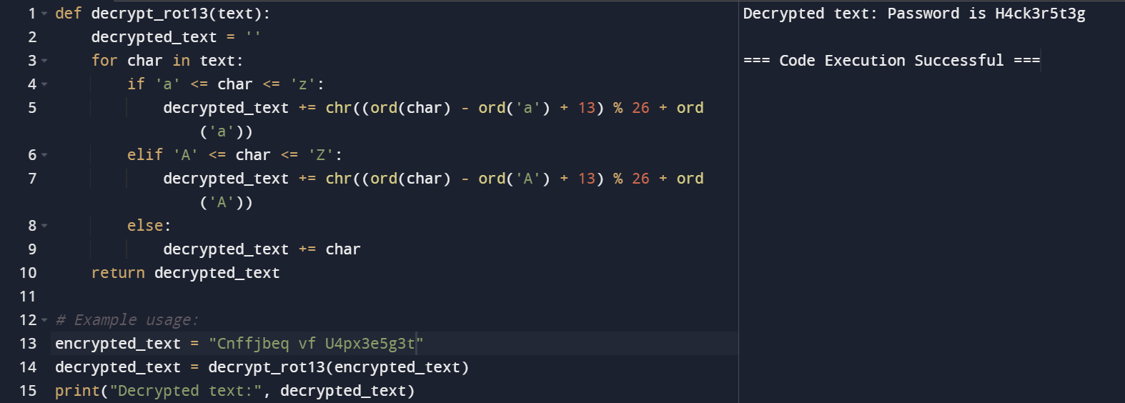above is an alternative python code that could be used to decrypt ROT13

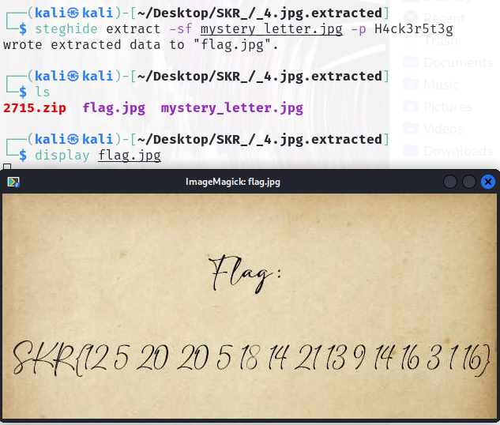

Finally, the command “steghide extract –sf mystery_letter.jpg -p H4ck3r5t3g” to extrct the file with the given passphrase.

In this command “–sf” indicates the source file to know where the data should be extracted from

“-p” this is to specify the passphrase after it for easier and faster access.

The command wrotes the extracted data into a new jpg file which is flag.jpg

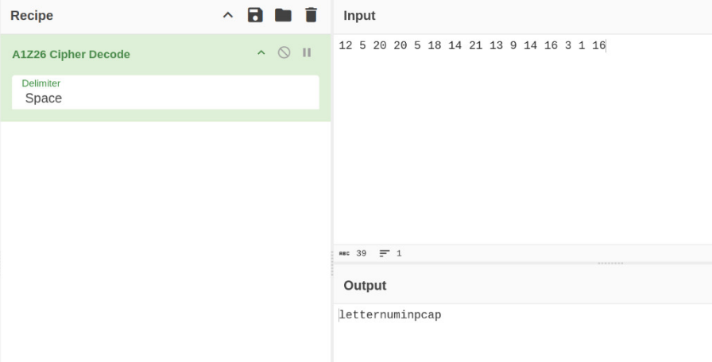

This image file has the following numbers (12 5 20 20 5 18 14 21 13 9 14 16 3 1 16), when trying to decrypt it using another website in this example it is cyberchef the decrypted message we get the actual flag:  
letternuminpcap

This message was encrypted using A1Z26 Cipher, what it does exactly is it replaces every letter of the alphabet with a corresponding number (A=1, B=2,etc...)

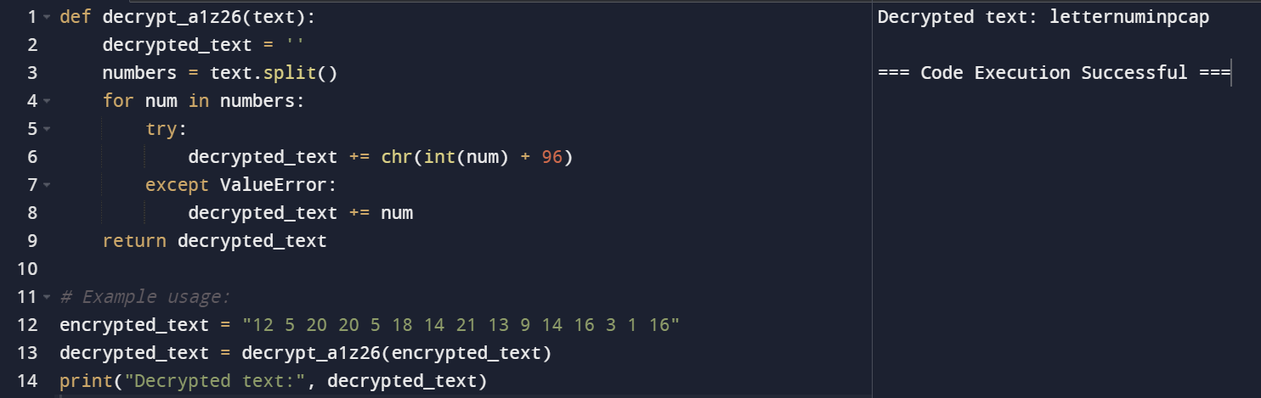

Here is an alternative python code that changes every letter with a corresponding number

Finally we test the flag to make sure it is correct

SKR{letternuminpcap}



# [De Tuna My Fish (Cryptography) (SKRCTF)](https://skrctf.me/challenges#De%20Tuna%20My%20Fish)

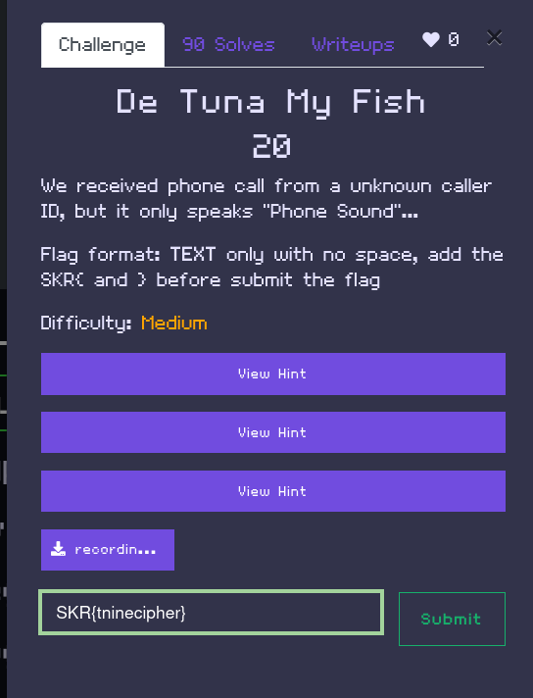

The [challenge](https://skrctf.me/challenges#De%20Tuna%20My%20Fish) depicted in the image states that a phone call was received from an unidentified caller, with the only audible content being a "phone sound." The format for the flag is specified as TEXT only, without spaces, and requires adding "SKR{" before submitting the flag. This suggests that the flag is embedded within the audio itself, requiring analysis of the sound to extract the correct text sequence.

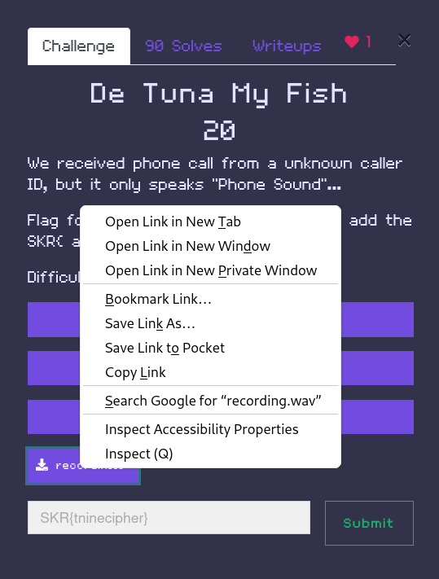

To acquire the audio file, simply right-click on the file and copy its link. Then, proceed to the terminal to execute further steps.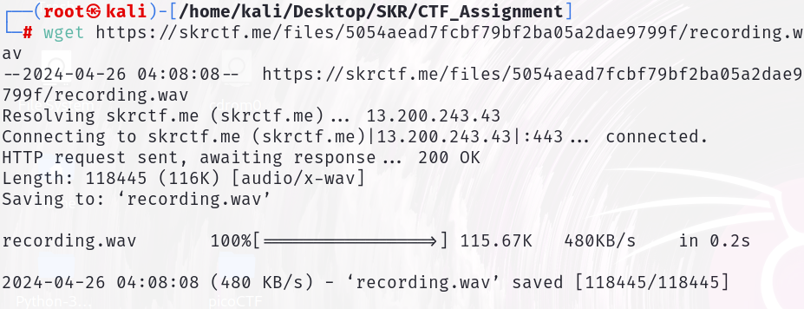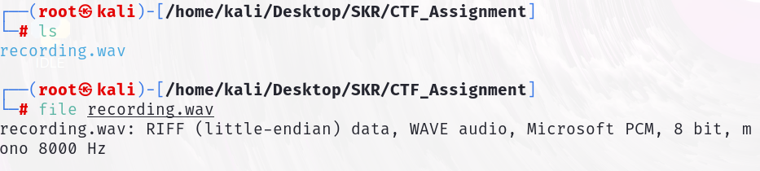

The "wget {URL}" command, utilized via the CLI (command-line interface), is employed to download a file into the directory where the user is currently located. Following this, to confirm the successful download, the "ls" command is entered to list all files in the directory. Subsequently, the "file" command is executed to determine both the file's data type and its extension, which in this case is ".wav".

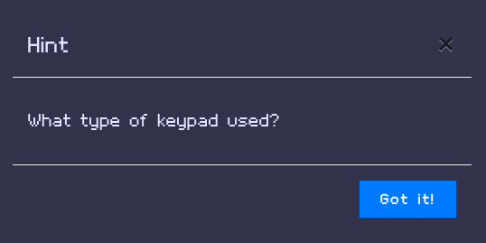

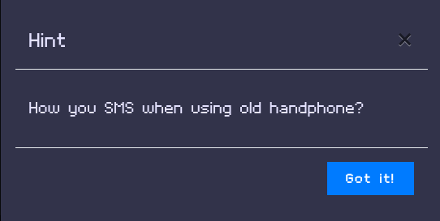

After downloading the file and inspecting its properties, the next step is to consider the hints provided. The first hint prompts us to determine the type of keypad used, while the second hint asks how one would send an SMS using an old handphone. Connecting these hints, we can infer that the flag likely pertains to something related to the keypad of an old handphone

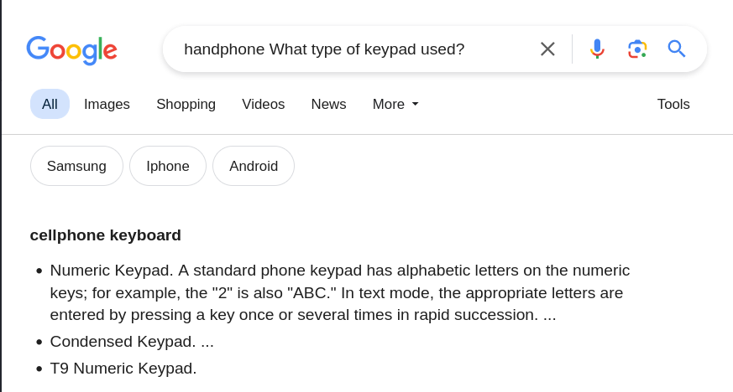

Upon investigating the type of keyboard used, a Google search for "handphone keypad" yields results indicating a "cellphone keyboard." Further examination reveals that this keyboard employs the T9 cipher.

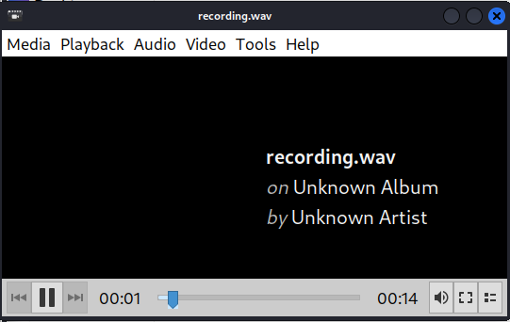

Upon playing the downloaded audio, it becomes apparent that it consists of tones resembling the pressing of keyboard buttons.

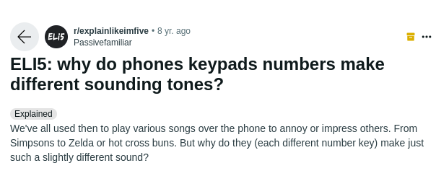

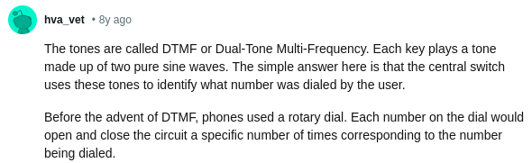

We proceed to conduct a Google search to understand more about the tones produced by keyboard buttons, investigating whether each tone corresponds to a specific character or function, and whether the sequence of tones forms any meaningful pattern. Our research reveals information about DTMF (Dual-Tone Multi-Frequency), indicating that each sound in the audio is encrypted in some manner.

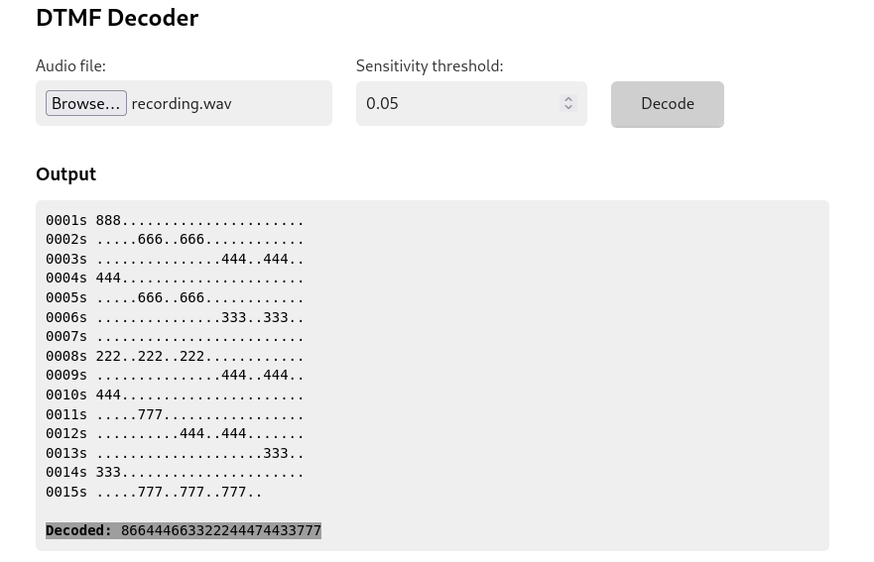

Having learned about DTMF, we proceed to search for and utilize a decoding tool to decipher the audio. Upon decoding, we discover that the output consists of a series of numbers. Given our previous discovery of the utilization of the T9 cipher for composing messages on old phones with only nine buttons, we now endeavor to decrypt the set of numbers into text using the T9 cipher.

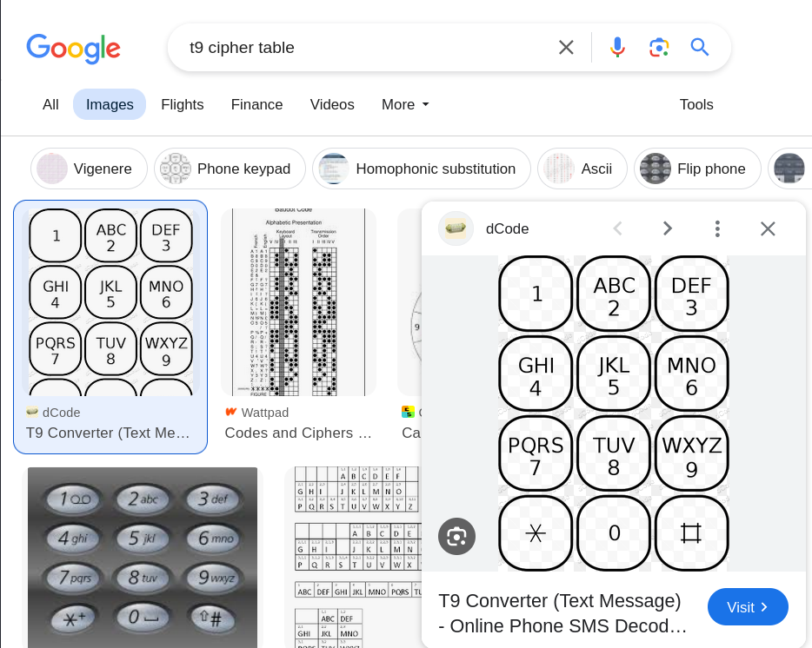

After conducting a search, we locate a T9 cipher table or keyboard to assist in decoding the numbers. Following the decoding process, we decipher the numbers as follows:

- 8 = t

- 66 = n

- 444 =

- 66 = n

- 33 = e

- 222 = c

- 444 = i

- 7 = p

- 44 = h

- 33 = e

- 777 = r

Combining these decoded numbers, we arrive at the text: "tninecipher".

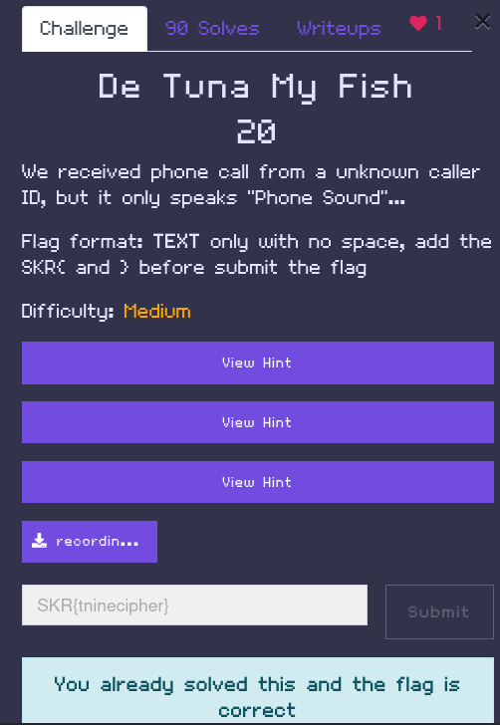

With the requirement to enclose the flag within "SKR{}" in mind, the final flag is "SKR{tninecipher}".

# [Slot Machine (Web) (SKRCTF)](https://skrctf.me/challenges#Slot%20Machine)

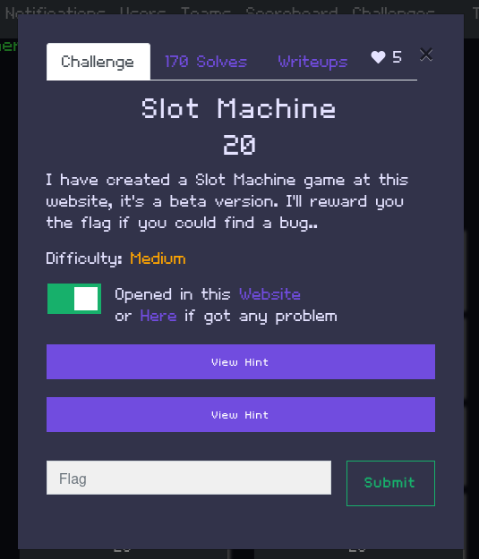

This challenge is situated under the Web category. A beta version of a Slot Machine game has been created at this website and it contains a bug. The flag is rewarded once the bug has been found and exploited. Hints given are as follows:

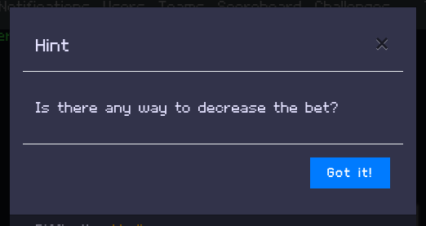

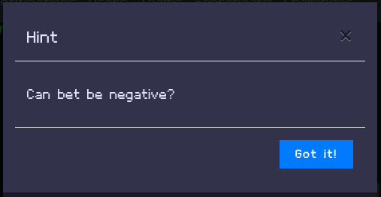

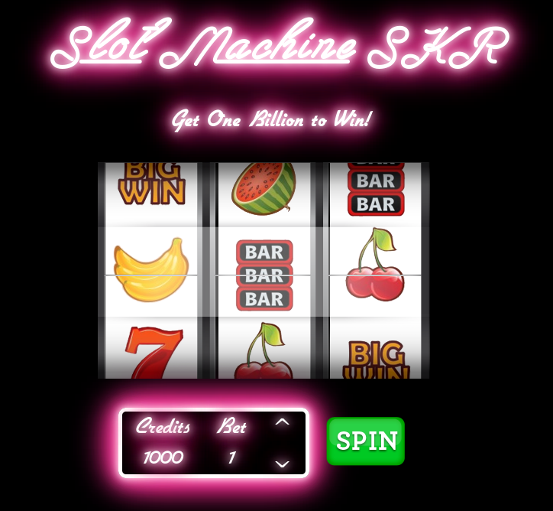

Upon clicking the website link, the player the greeted with the slot machine. The slot machine consists of the slots, Credits amount, Bet amount and ‘SPIN’ button. Based on the description, the player needs to get 1,000,000,000 to win and get the flag.

Spinning the slot machine and it can be observed as follows:

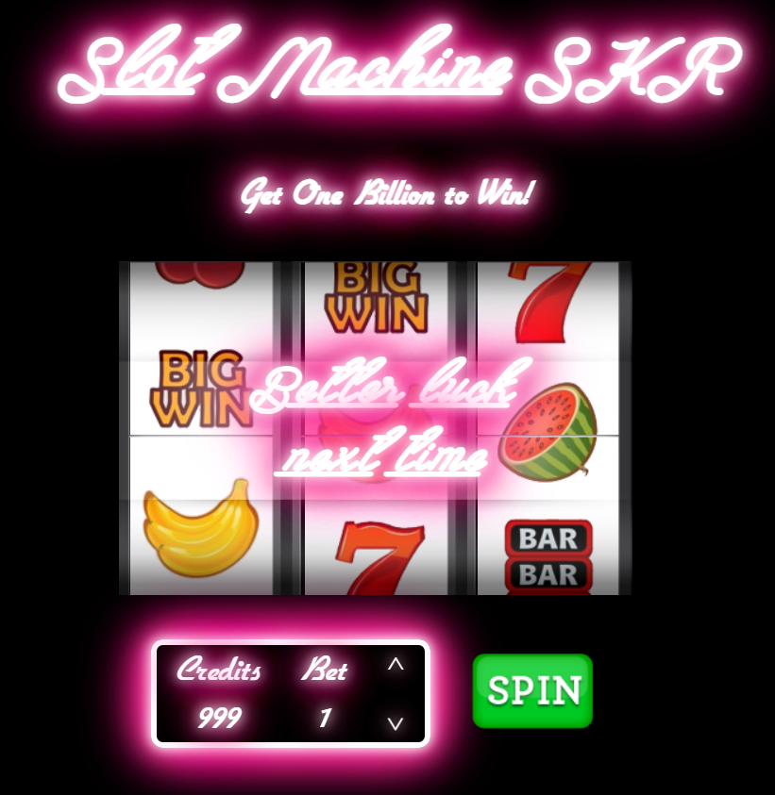

A losing spin with a bet of 1. The credits are deducted by 1 from 1000 to 999.

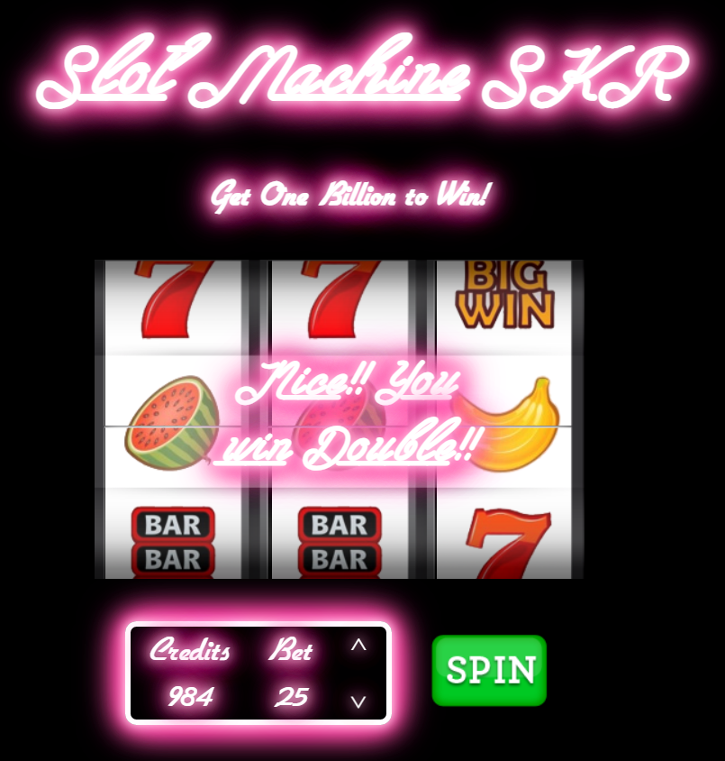

A winning spin with a bet of 25. The winning is double and raising the credit to 984.

Reaching to 1 billion will take a long time if the usual route of just spinning the slot machine is taken. Hence, as stated in the challenge description the bug will the searched for and exploited in order to obtain the flag.

1. Viewing the source file

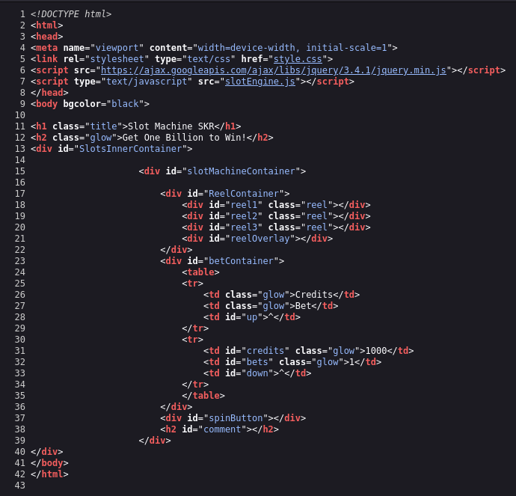

First, the page source of the slot machine is viewed. By examining the source file, it can be seen that the website is a simple slot machine game with a credit system. The game allows users to spin the reels and win credits based on the outcome. There's a condition in the JavaScript code that if the player's credit reaches 1,000,000,000, a flag will be revealed. This HTML file contains the structure and layout for the slot machine game, while the external JavaScript and CSS files are used to add interactivity and styling to the game.

1. Examining the JavaScript code

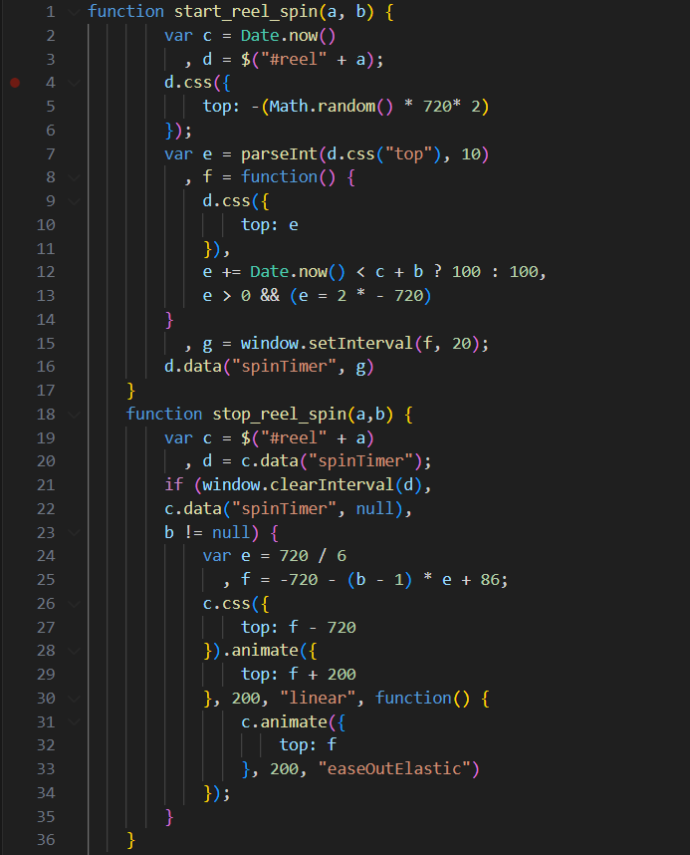

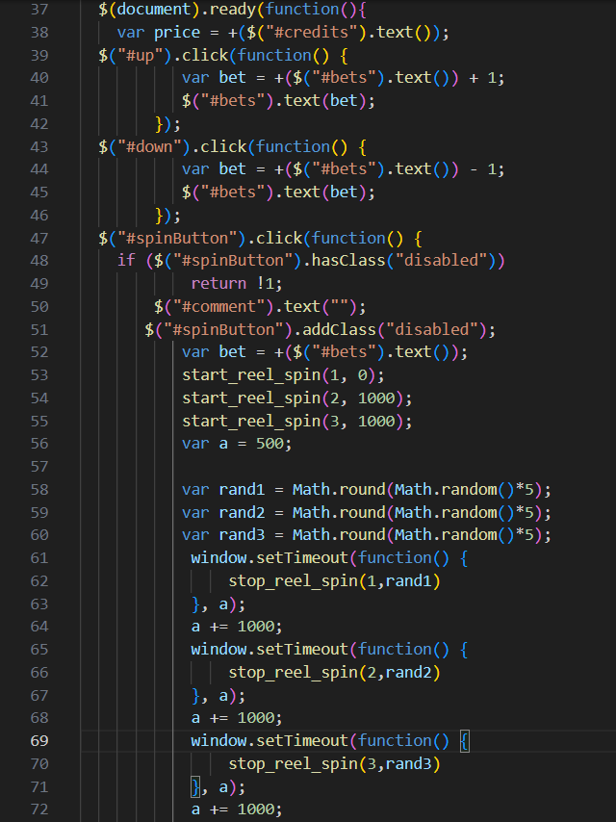

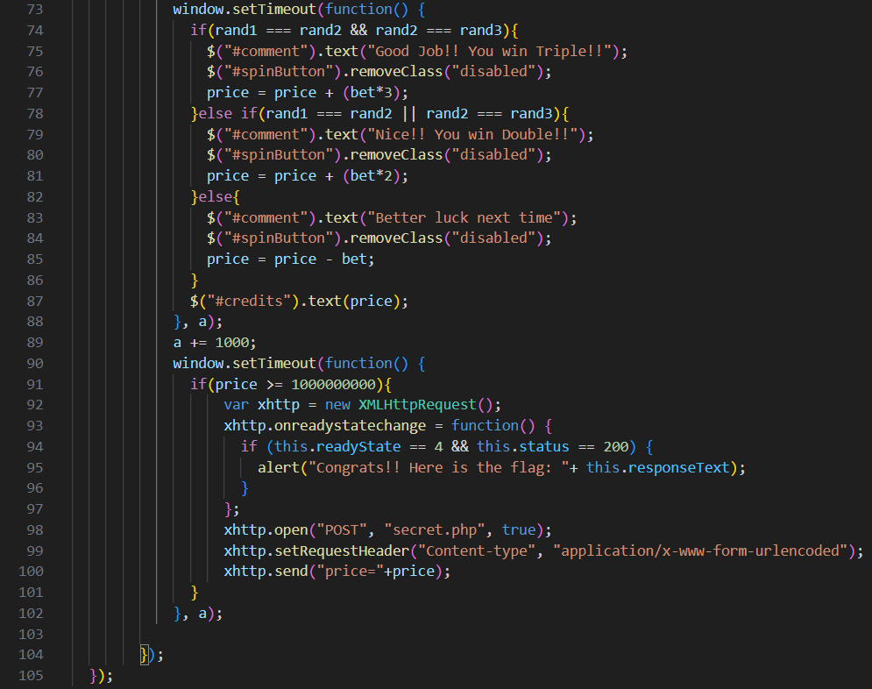

The JavaScript code (slotEngine.js) contains the logic for the slot machine game. By examining the code, it is observed that the game spins three reels with random numbers. It is also apparent that if all three reels have the same number, the credit is increased by three times the bet amount. If two reels have the same number, the credit is increased by two times the bet amount. Otherwise, the bet amount is deducted from the credit. When the player wins and their credit reaches 1,000,000,000, an AJAX request is sent to a server-side PHP script (secret.php) with the player's credit as a parameter and presumably reveals the flag. However, the credit or bet amount cannot be modified directly through the JavaScript code.

1. Bug Exploitation

The vulnerability lies in the insufficient validation of the price variable before triggering the AJAX request. The game only checks if the player's credits (price) are greater than or equal to 1,000,000,000 to trigger the flag. There's no validation to ensure that the credits are obtained legitimately or that the value is within reasonable bounds.

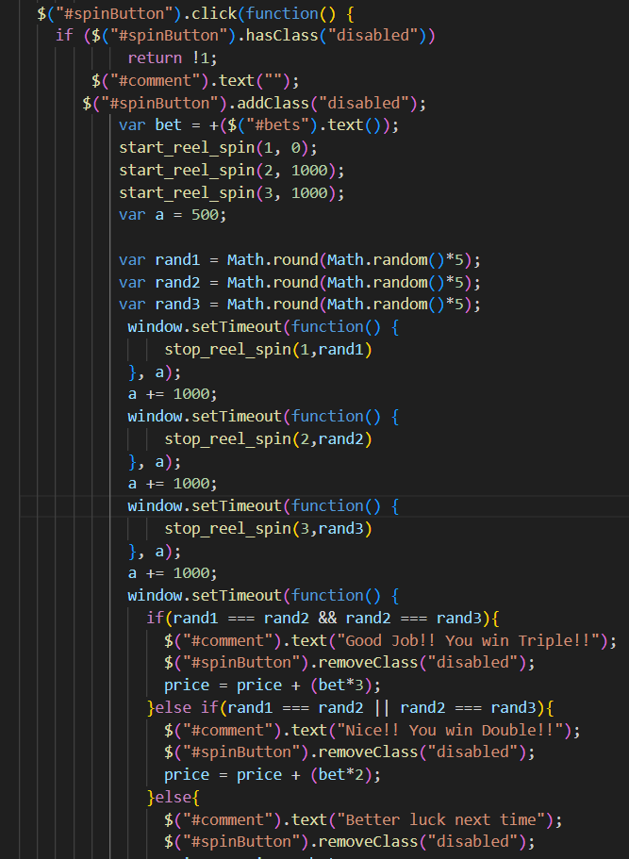

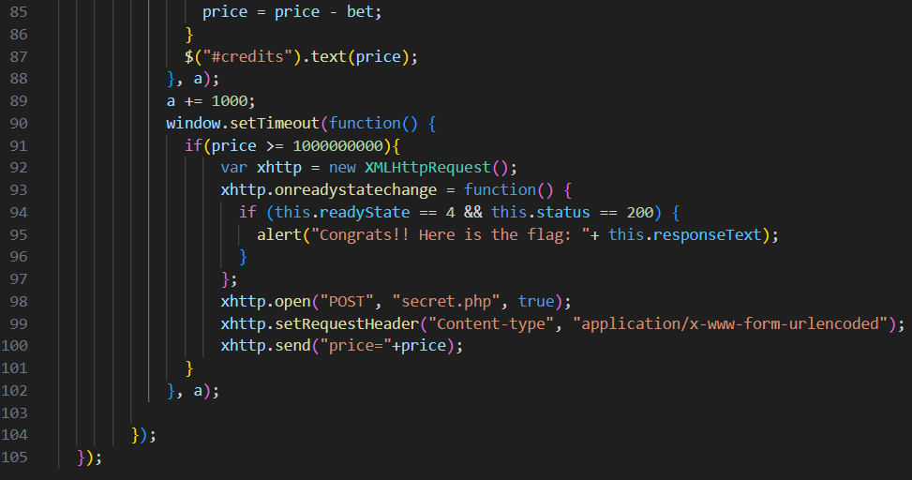

The condition if(price >= 1000000000) in this area of the code, which determines whether the player's credits (price) have surpassed 1,000,000,000, is where the vulnerability is. AJAX request to reveal the flag is made to a server-side script (secret.php) if this condition evaluates to true.

The player's credits aren't properly enforced or validated, which is the bug. Players could be able to set the price variable to 1,000,000,000 or more without really earning or rightfully gaining that number of credits through gameplay because it is being modified directly on the client-side. Without fulfilling the intended gaming requirements, players can take advantage of the game's lack of validation and trigger the flag-revealing condition.

Exploiting this vulnerability can be done in multiple ways:

* Manipulating the client-side credits directly to reach 1,000,000,000.
* Manipulating the bet amount to cause the player's credits to go below 0 or above 1,000,000,000.

Method 1: Python Code

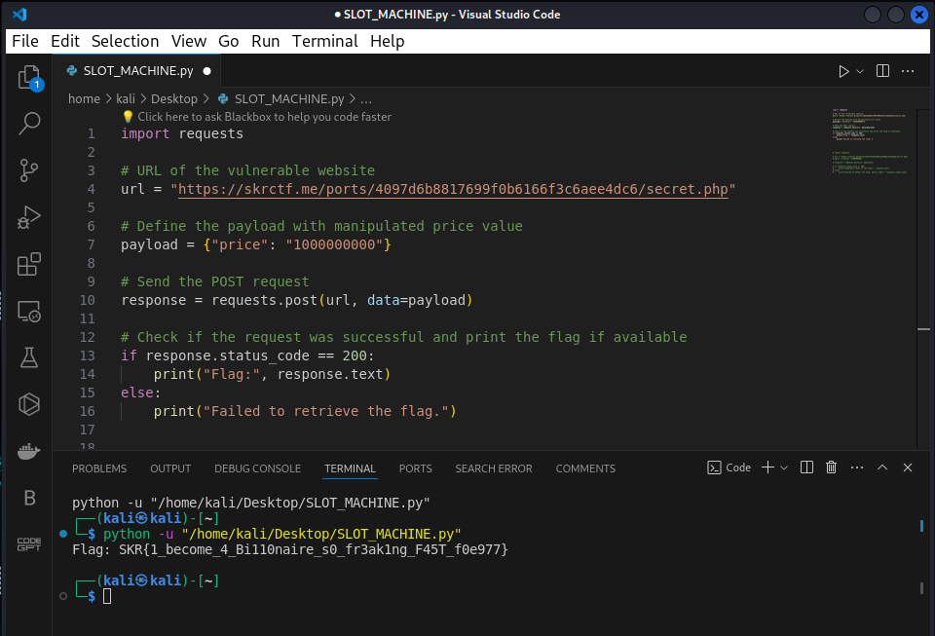

1. import requests

This line imports the requests library, which is used to send HTTP requests in Python.

1. url = "https://skrctf.me/ports/32d3f74be4bf0b6c2de4862cbcf9aa8a/secret.php"

The flag can be acquired from this line, which specifies the URL of the vulnerable website.

1. payload = {"price": "1000000000"}

The payload is specified here, and it will be delivered with the POST request. In the payload, there is only one key-value pair: "price" is the key, and "1000000000" is the value, which stands for the fabricated credit value.

1. response = requests.post(url, data=payload)

Using the payload (payload) that is supplied, this line makes a POST request to the given URL (url). You can send a POST request using the requests.post() function, and you can define the data to be delivered in the request body using the data parameter.

1. if response.status_code == 200:

print("Flag:", response.text)

else:

print("Failed to retrieve the flag.")

This is where the response's status code is verified with, 200, signifies a successful request. The output the flag the server returned (response.text) if the request was successful. If there was a problem with the server or connectivity, for example, and the request failed, the failure message will be printed out.

1. The script is run, and the flag is obtained.

Method 2: Console (Credit Manipulation)

In the code snippet below, variable ‘price’ represents the player’s credits. By directly manipulating the price variable on the client-side, the desired value of 1 billion can be set. This is done through the ‘Inspect Element’ and under the Console tab.

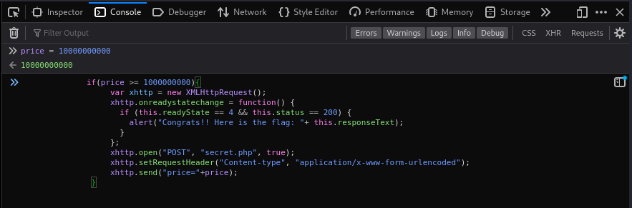

The typical gameplay technique of collecting credits through spins is bypassed and the threshold needed to trigger the flag-revealing condition is reached by setting price to 1,000,000,000.

There's a condition that checks if the player's credits (price) are greater than or equal to 1,000,000,000. When this condition evaluates to true (which it will if price is set to 1,000,000,000), it executes the code inside the if statement block.

Inside the if statement block, an AJAX request is sent to a server-side script (secret.php) to reveal the flag. This code creates an XMLHttpRequest object (xhttp) and sends a POST request to the server-side script (secret.php) with the price parameter set to 1,000,000,000. If the request is successful (status code 200), the flag returned by the server is displayed in an alert box.

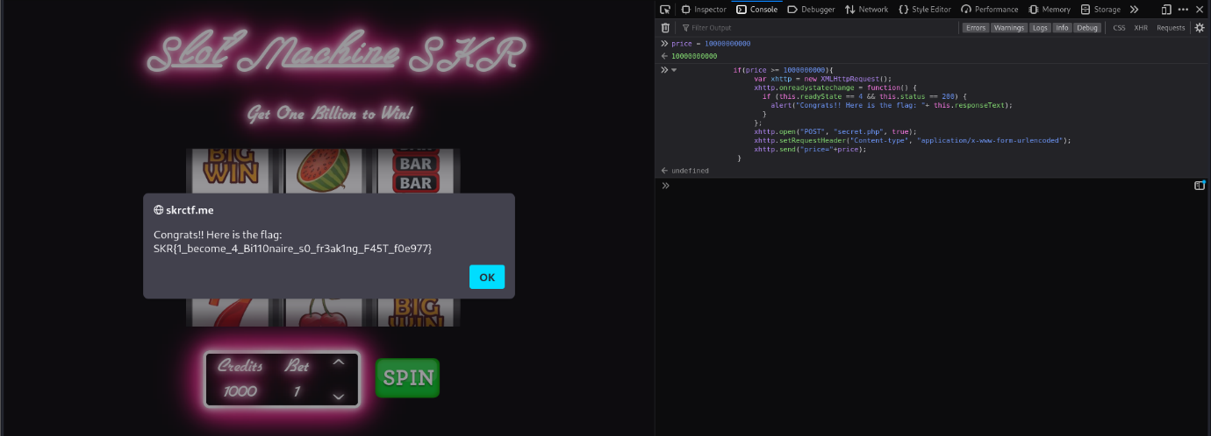

Method 3: Console (Bet Manipulation)

document.getElementById("bets").innerHTML = "-100000000000000";

The line above is a JavaScript statement that manipulates the content of an HTML element with the id attribute set to "bets"

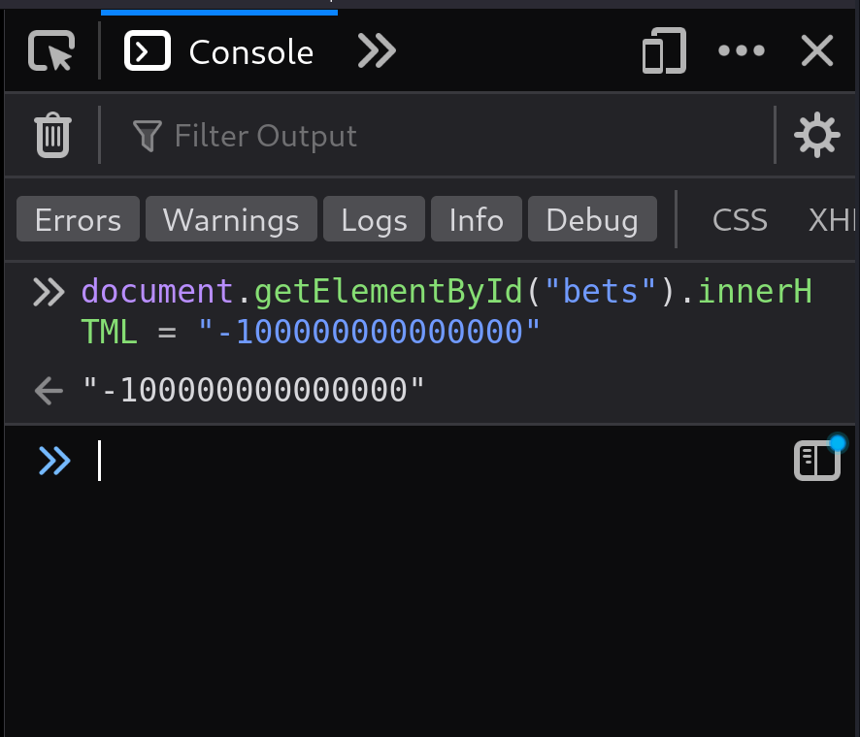

1. document.getElementById("bets"):

* ‘document’ refers to the Document Object Model (DOM) of the HTML document currently loaded in the browser.
* ‘getElementById("bets")’ is a DOM method used to retrieve an HTML element with a specific id attribute value.
* In this case, it's looking for an element with the id "bets".

1. .innerHTML:

* innerHTML is a property of DOM elements that represents the HTML content within the element, including any nested elements.
* By setting this property, you can change the HTML content of the selected element.

1. = "-100000000000000";:

* This part of the statement assigns a new value to the innerHTML property of the element with id "bets".
* The assigned value is a string "-100000000000000".

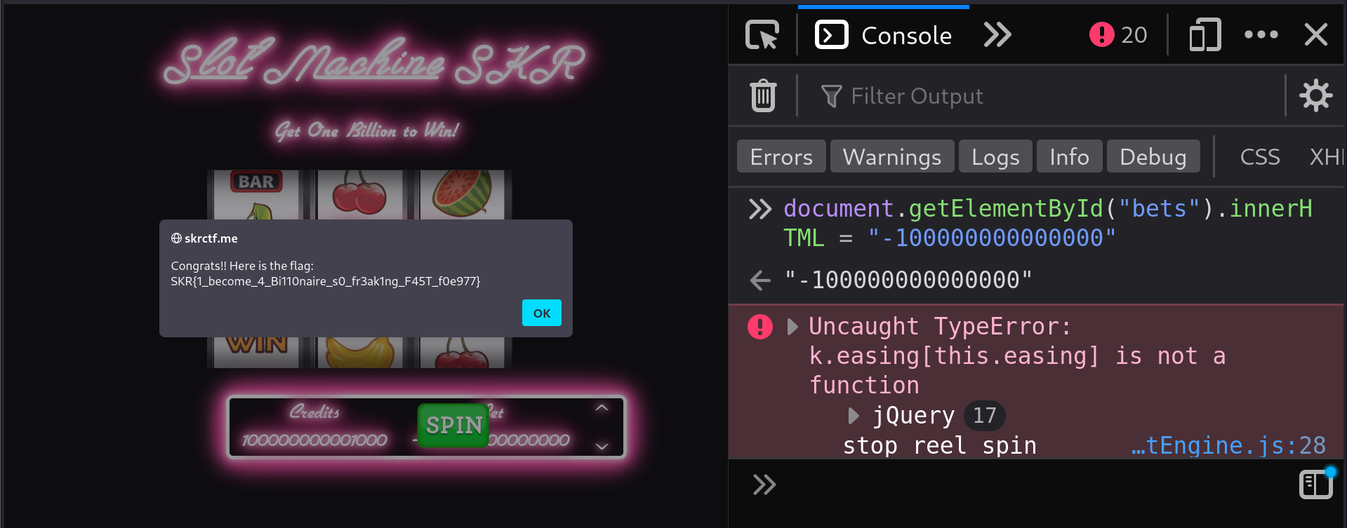

The line paper, which summarises everything.getElementById(); say "bets"innerHTML = "-100000000000000"; replaces the content of an HTML element with the id "bets" with the string "-100000000000000". By doing this, the element's visible text or HTML content is essentially changed to "-100000000000000".

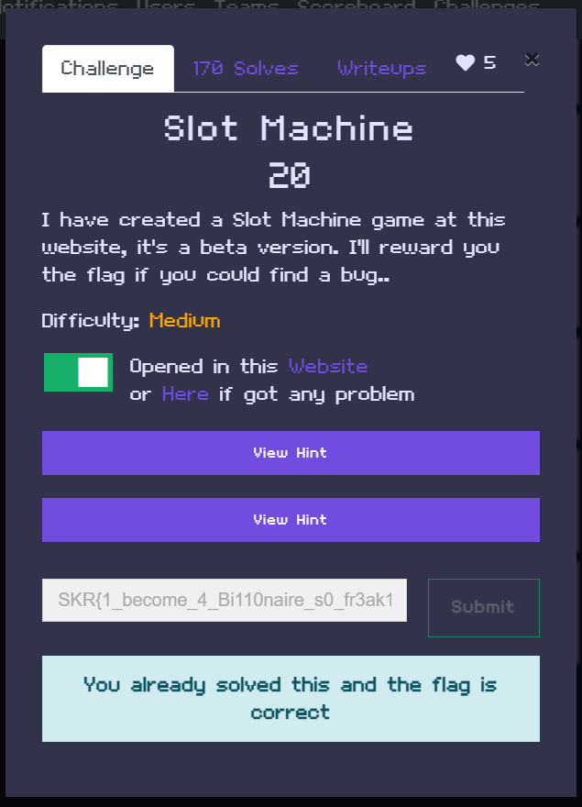

# REFERENCES

* Movavi. (2024, April 3). What Is WAV File? | All About .wav Format – Movavi Converter. Movavi.com. <https://www.movavi.com/learning-portal/wav-file.html>

‌

* Definition of cellphone keyboard. (2024). PCMAG; PCMag. <https://www.pcmag.com/encyclopedia/term/cellphone-keyboard>

‌

* Reddit - Dive into anything. (2016). Reddit.com. <https://www.reddit.com/r/explainlikeimfive/comments/453e3t/eli5_why_do_phones_keypads_numbers_make_different/?rdt=46972>

‌

* DTMF Decoder. (2024). Netlify.app. <https://dtmf.netlify.app/>

‌

* T9 Converter (Text Message) - Online Phone SMS Decoder, Translator. (2024). T9 Converter (Text Message) - Online Phone SMS Decoder, Translator. Www.google.com. <https://www.google.com/imgres?imgurl=https://www.dcode.fr/tools/phone-keypad/images/keypad.png&tbnid=WbiSHB1y-PwvKM&vet=1&imgrefurl=https://www.dcode.fr/t9-cipher&docid=aYrWwnC_IHnujM&w=507&h=692&source=sh/x/im/m1/1&kgs=577d14bcd27dceda&shem=abme,trie>

‌

* *Equation Solver*. (2024). Dcode.fr. <https://www.dcode.fr/en>
* *CyberChef*. (2024). Github.io. <https://gchq.github.io/CyberChef/>
* Ajax introduction. (n.d.). https://www.w3schools.com/xml/ajax_intro.asp
* JavaScript HTML dom. (n.d.). https://www.w3schools.com/js/js_htmldom.asp
* MozDevNet. (n.d.-a). *HTTP headers - http: MDN*. MDN Web Docs. https://developer.mozilla.org/en-US/docs/Web/HTTP/Headers
* MozDevNet. (n.d.-b). *Introduction to the DOM - web apis: MDN*. MDN Web Docs. <https://developer.mozilla.org/en->
* US/docs/Web/API/Document_Object_Model/Introduction
* *Python requests post() method*. Python Requests post Method. (n.d.). https://www.w3schools.com/python/ref_requests_post.asp
* Real Python. (2024, February 28). *Python’s Requests Library (guide)*. https://realpython.com/python-requests/
* MozDevNet. (n.d.-a). *Document.getElementById() method - web apis: MDN*. MDN Web Docs. https://developer.mozilla.org/en-US/docs/Web/API/Document/getElementById